Gdfgdfg

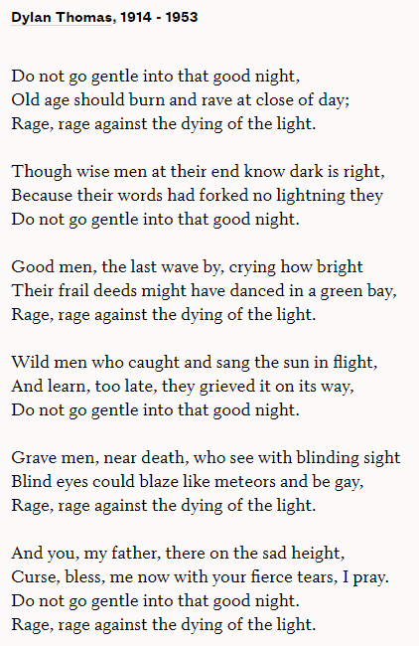

Fgfdgfdg

Dgfdgfdg